NESTLE AGENTIC DOCUMENT EXTRACTION & VALIDATION WORKFLOW

Overview
The import clearance process runs across 9 sequential steps, organised into three phases.

Phase 1 - Document Receipt & Pre-validation

Step 1 - Pre-alert / Scanned Document Receipt

Nestle receives pre-alerts or scanned copies of clearing documents from vendors and suppliers before or upon shipment arrival. Documents arrive through email or shared drives in mixed formats and quality.
- Daily Throughput: 5-10 BOEs per day; 25-50 documents per day
- Document Types: Invoices, packing lists, freight manifests, certificates of origin, BOEs
- Input formats: PDF, Excel, scanned images (JPEG/PNG)
- Languages: English and French (mixed within documents)
- Transmission methods: Email / shared drive / direct upload

Step 2 - IMPEX Document Validation (AI Agentic System Target <> AYADATA)
The IMPEX team reviews all received clearing documents against a validation checklist before transmitting to the clearing agent. This step ensures that only clean, verified documents proceed to customs. This is the first primary automation target for Phase 1.
- Current Staffing: 2 IMPEX staff members (fully manual)
- Accuracy Benchmark: ~98% human accuracy rate
- Error Impact: Incorrect duty payments, revenue exposure, GRA penalties
- Checks Performed: Field completeness, consistency across docs, format validation, supplier match
- AI Target: OCR extraction + field-level cross-check + confidence scoring + discrepancy flagging
- Human-in-loop: Human reviewer acts on AI-flagged discrepancies before transmit

Step 3 - Transmit to Clearing Agent
Once documents have passed internal validation, the IMPEX team transmits the full document package to the preferred clearing agent. This is a critical handoff gate - errors not caught at Step 2 will propagate into the BOE generation at Step 4.
- Recipient: Preferred customs clearing agent.
- System Used: ICOM (Ghana Revenue Authority customs platform)
- Gate Risk: Undetected errors carry forward to BOE; correction post-BOE is costly
- Transmission: Scanned / digital document package

Phase 2 - Customs Processing & BOE Verification
Step 4 - Agent Processing in ICOM
The clearing agent enters customs and regulatory data into the ICOM system (Ghana Revenue Authority). This triggers concession assessment and generates a draft Bill of Entry (BOE) - the formal customs declaration specifying the duty amount Nestle must pay.
- System: ICOM (GRA - Ghana Revenue Authority platform)
- Output: Draft Bill of Entry (BOE)
- Processes: Concession assessment, tariff classification, regulatory validation
- Edge case: Some BOE fields (e.g. freight number) may not have a direct source in vendor documents

Step 5 - Agent Sends Draft BOE for Verification
The clearing agent sends the generated draft BOE back to the Nestle IMPEX team. This triggers the most critical verification step in the workflow. Nestle requires the original scanned clearing documents from Step 1 to perform the verification against the BOE - this dependency must be preserved in the automated system.
- Document Format: Non-fillable PDF (not a form template; BOE auto-population is out of Phase 1 scope)
- Typical Batch: Up to 6 BOEs received simultaneously
- Dependency: Original scanned clearing docs (Step 1) required for cross-verification
- Scope Note: BOE generation / field auto-population is out of scope for Phase 1

Step 6 - IMPEX Checks BOE Against Supporting Documents (AI Agentic System Target <> AYADATA)
This is the primary automation target for Phase 1 and the most critical step in the workflow. The IMPEX team manually cross-checks every field on the BOE against the original supporting documents. The AI system will extract fields from both the BOE and supporting documents, compare them, and flag any discrepancy for human review. Confirmed clean BOEs are forwarded to Finance for payment.
- Fields Verified: Exporter name/address, invoice number, freight value, commodity codes, quantity, tariff rates, supplier details
- Discrepancy Handling: System flags mismatches; tolerance rules configurable per field type (e.g. 'Limited' vs 'Ltd' can be configured as acceptable match)
- Edge Cases: Some BOE fields not found in vendor documents - handled by exception rules defined with Nestle
- Language: English <-> French field equivalences must be mapped in the system
- Output: Verified BOE forwarded to Finance; discrepancies returned to IMPEX / agent
- Human Gate: Human reviewer required before Finance trigger; AI assists, does not replace

Phase 3 - Payment & Delivery
Step 7 - Finance Pays Duty
Upon receiving the verified BOE from IMPEX, the Nestle Finance team processes the duty payment to Ghana Revenue Authority. The accuracy of this step depends entirely on upstream verification - any uncaught discrepancy at Step 6 directly impacts the duty amount and can result in financial penalties, overpayments, or underpayments.
- Payee: Ghana Revenue Authority (GRA)
- Trigger: Verified BOE forwarded by IMPEX
- Financial Risk: Errors in BOE lead to wrong duty amount, potential GRA penalties
- Process: Internal finance approval, bank transfer, duty receipt issued

Step 8 - Ship / Airline Release & Other Payments
Once duty is paid, the clearing agent facilitates the formal release of goods from the port or airport. Additional charges such as demurrage, port handling fees, and airline release fees are settled at this stage.
- Actions: Formal goods release, port/airline charge payments
- Parties: Clearing agent, Port Authority / airline, Nestle Finance
- Documents: Duty payment receipt, final validated BOE
- Risk: Delays increase storage and demurrage costs

Step 9 - Delivery, Offloading & Container Return
The final stage of the import cycle. Goods are physically delivered to the Nestle warehouse or designated location, offloaded, and inspected. The shipping container is returned to the carrier within the agreed free-time window to avoid demurrage charges. All documentation is archived for audit purposes.
- Activities: Delivery, offloading, goods quality check, container return
- Container Deadline: Must be returned within carrier-specified free-time window
- Archive: All BOEs, invoices, and clearance documents filed for audit trail
- Outcome: Import cycle complete; goods received into Nestle inventory

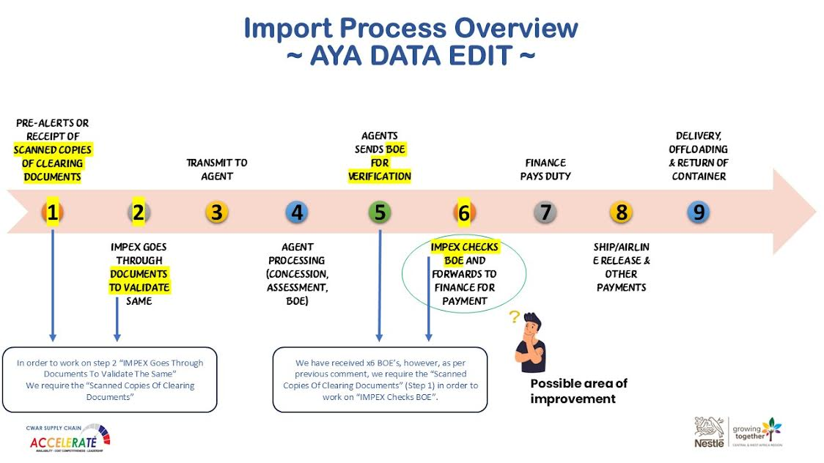

AI Automation Scope - Phase 1 - AYADATA
The AI system targets Steps 2 and 6, which account for the majority of manual effort and error risk. The system will be deployed on-premise at Nestle's facility.

Capability | In Scope (Phase 1)
OCR Extraction | PDF, scanned images, handwritten docs; English and French
Field Cross-Verification | BOE vs all supporting documents per shipment
Discrepancy Flagging | Field-level mismatch detection with configurable tolerance rules
Confidence Scoring | Per-field extraction confidence displayed to reviewer
Human-in-Loop Review | Reviewer UI to inspect flagged fields and approve / reject
Multi-doc Comparison | Up to 5 supporting docs per BOE cross-referenced simultaneously
Bilingual Mapping | English <-> French field equivalences for common terms

Data & Technical Requirements
Sample Data Required from Nestle
- Minimum 2 BOEs with all corresponding supporting documents (4-5 docs per BOE)
- Scanned documents in all available formats (PDF, image) from multiple vendors
- Historical cases of correctly and incorrectly matched documents for model evaluation
- At least 2 sample documents from different vendor/supplier templates
- Edge case examples where BOE fields cannot be sourced from vendor documents

Process Knowledge Required
- Validated list of all fields to be checked on each BOE type
- Tolerance rules per field (exact match, fuzzy match, abbreviation accepted, etc.)
- English <-> French glossary for common customs terms used in documents
- Decision rules for edge cases (e.g. how freight number is determined when absent from vendor docs)
- Step-by-step walkthrough of the current manual validation checklist used by IMPEX staff

Infrastructure
- On-premise deployment at Nestle facility
- Server specifications, storage capacity, and processing specs to be confirmed
- Network access requirements for on-premise AI inference

Risk | Detail | Mitigation
Accuracy below 98% | AI must match or exceed human benchmark; financial errors are costly | Human-in-loop review gate before Finance trigger
OCR quality on scanned docs | Poor scan quality may reduce extraction accuracy | Confidence scoring + manual review flag for low-confidence fields
Multi-language docs | English/French mixing may confuse field extraction | Bilingual field mapping and language detection pre-processing
Edge case BOE fields | Freight number etc. may not exist in vendor docs | Exception rules defined with Nestle; default values or manual input
Inconsistent vendor formats | 100+ vendors with different document layouts | Template-agnostic OCR; vendor-specific post-processing rules if needed
Data privacy (NDA) | NDA signed Feb 2026; real documents now shareable for dev/test | Secure on-premise deployment; data not to leave Nestle environment

